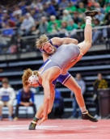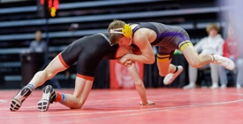

­­

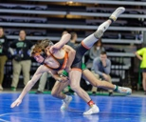

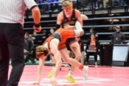

112-56

104-56

78-45

111-39

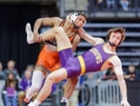

96-51

71-70

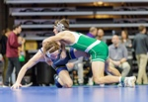

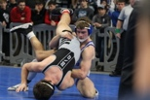

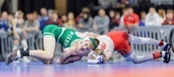

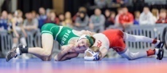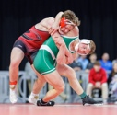

67-52

69-51

158-66

106-62

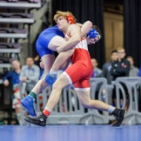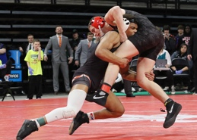

85-70

100-56

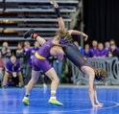

108-62

94-72

66-62

99-39

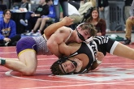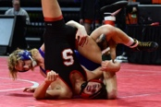

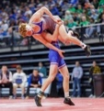

78-65

73-70

80-44

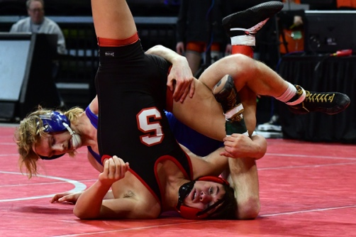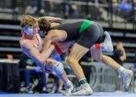

111-27

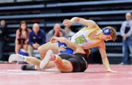

96-82

120-66

**Winner Peyton Fridrich Beresford Alcester Hudson BAH Final vote 118-85**