Monday Motivation: Mastering Focus as the Postseason Approaches
by Jon Gums
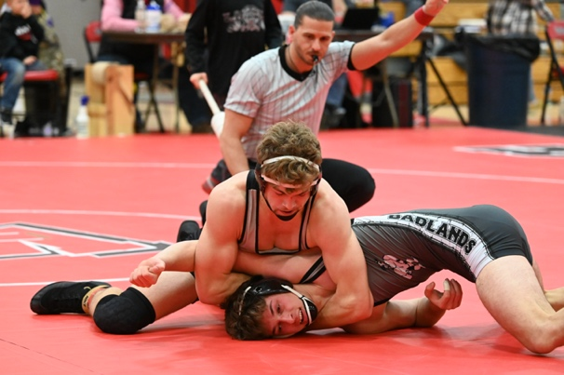
As the wrestling season inches towards its climax, athletes find themselves at a critical juncture where focus can be the difference between victory and defeat. The postseason, with its heightened intensity and pressure, demands a level of concentration that goes beyond the physical. This Monday, let's delve into the art of staying a focused athlete/wrestler, exploring the right actions, and providing a comprehensive list of to-dos to be a stellar teammate and team leader.
Understanding the Importance of Focus:
In the world of wrestling, where split-second decisions and precise execution are paramount, maintaining focus is akin to wielding a powerful weapon. The postseason, with its win-or-go-home scenarios, elevates the stakes, making mental acuity as crucial as physical prowess.
Focus is not just about blocking out distractions; it's about channeling one's energy and attention towards the task at hand. It's the ability to navigate pressure, maintain composure in the face of adversity, and execute with precision when it matters most. As the postseason looms, staying a focused athlete becomes a non-negotiable aspect of success.
Doing the Right Things:
- Visualization Techniques: Engage in regular visualization sessions. Picture yourself executing flawless moves, dominating opponents, and standing victorious on the podium. Visualization enhances muscle memory and primes the mind for success.
- Goal Setting and Review: Clearly define your postseason goals and regularly review them. Whether it's a specific record, a state championship title, or personal performance benchmarks, having clear goals provides a roadmap for your focus.
- Mindfulness Practices: Incorporate mindfulness practices into your routine. Techniques such as meditation and deep breathing can help calm nerves, enhance focus, and improve overall mental resilience.
- Structured Training Sessions: Tailor your training sessions to mirror the intensity of postseason competition. Simulate match scenarios, practice under time constraints, and focus on refining high impact moves one go to move from your feet, one from on bottom and a pinning combination. The goal is to condition both the body and mind for the challenges ahead.
- Strategic Game Planning: Work closely with coaches to develop a strategic game plan for the postseason. A good coach would have done this along time ago, but no better time to define it if they have not. Analyze potential opponents, identify strengths and weaknesses, and formulate a personalized approach for each match. A well-thought-out strategy can provide a mental edge.
- Recovery Protocols: Ensure proper recovery to maintain physical and mental freshness. The demands of the postseason can be grueling, and a well-rested body contributes significantly to sustained focus and performance.
To-Dos as a Good Teammate and Team Leader:
- Lead by Example: Demonstrate the level of focus and commitment expected from the team. Your actions will speak louder than words, setting a standard for your teammates to emulate.
- Supportive Environment: Foster a supportive team environment. Encourage open communication, offer assistance to teammates struggling with aspects of their wrestling, and create a culture where everyone feels valued.
- Motivational Presence: As a team leader, be a source of motivation. Recognize and celebrate individual and team achievements and offer words of encouragement during challenging times. Your positivity can be contagious.
- Team-Building Activities: Engage in team-building activities outside of the wrestling room. Whether it's a shared meal, a team outing, or collaborative exercises, building strong bonds off the mat contributes to a cohesive and focused team on the mat.
- Mentorship: Take on a mentorship role for younger or less experienced teammates. Share your insights, provide guidance, and instill the importance of focus and discipline in both training and competition.
- Accountability: Foster a culture of accountability. Encourage teammates to set their own goals, hold themselves to high standards, and contribute actively to the team's collective success.
- Communication Channels: Keep communication channels open. Actively listen to your teammates' concerns, provide constructive feedback, and ensure everyone feels heard and supported. Effective communication is key to maintaining focus as a team.
Conclusion:
As the postseason approaches, the spotlight intensifies, and the margin for error narrows. Staying a focused athlete in these crucial moments is not just a personal endeavor; it's a collective effort that permeates the entire team. By adhering to the right practices and fulfilling the responsibilities of a good teammate and team leader, wrestlers can forge a path to success that extends beyond individual achievements to the triumph of the entire team. This Monday, let focus be your greatest ally on the journey to postseason glory.

