1-2-24
EEK 60 Linton 13
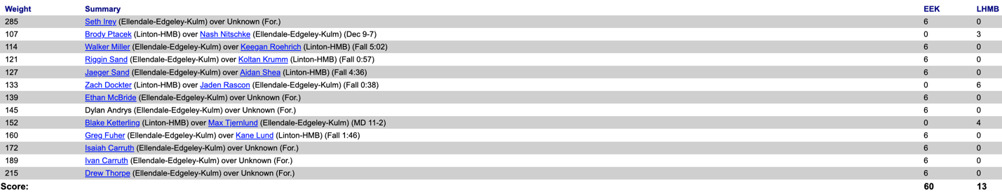
EEK 66 Northern Cass 6
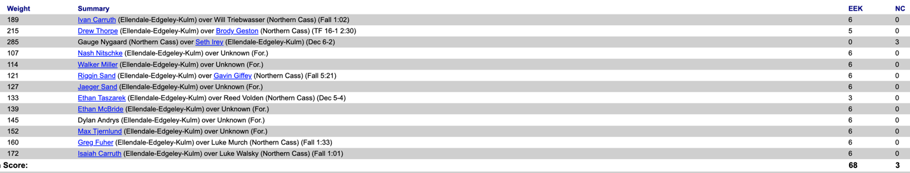
Border West 39 Breckinridge/Wahpeton 27
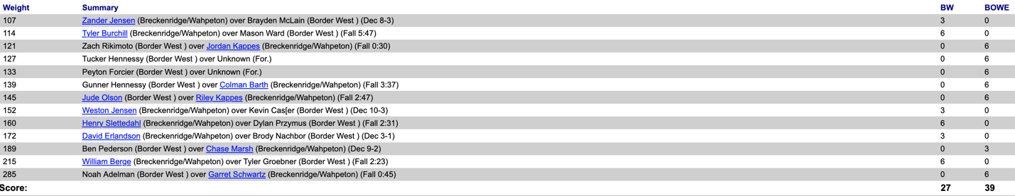
Fargo North 60 Fargo South 18
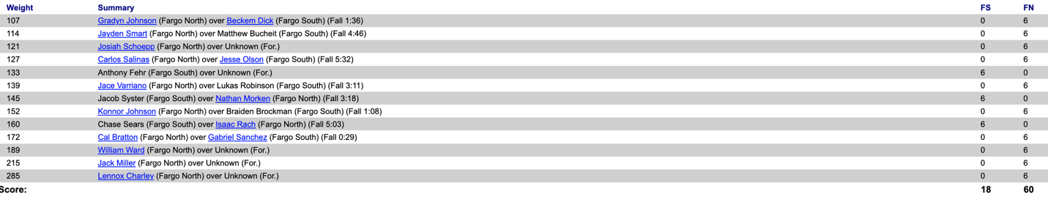
1-4-24
Bismarck St. Mary’s 48 TMCHS 24
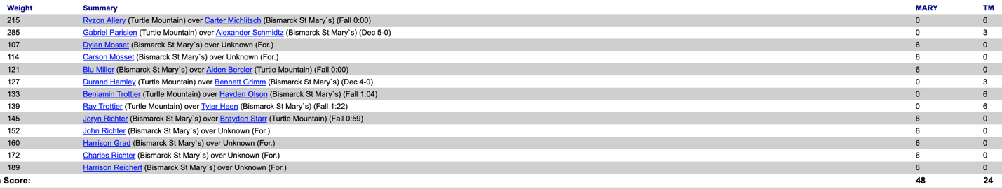
Bismarck 57 TMCHS 15
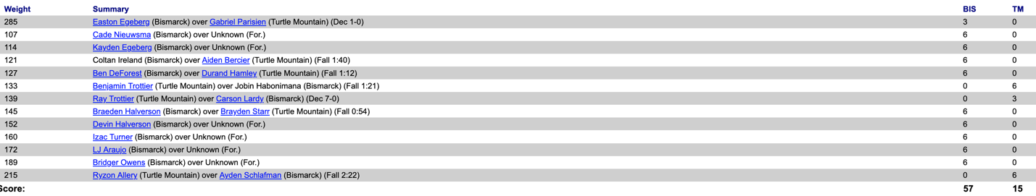
Bismarck 46 St. Mary’s 13
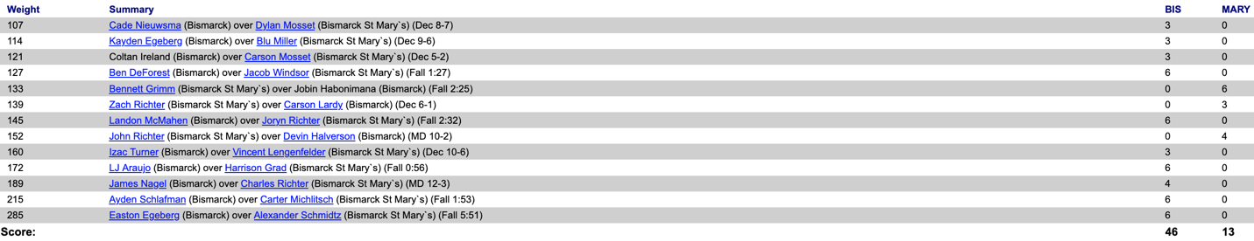
Hillsboro/CV 48 MayPort-CG 27
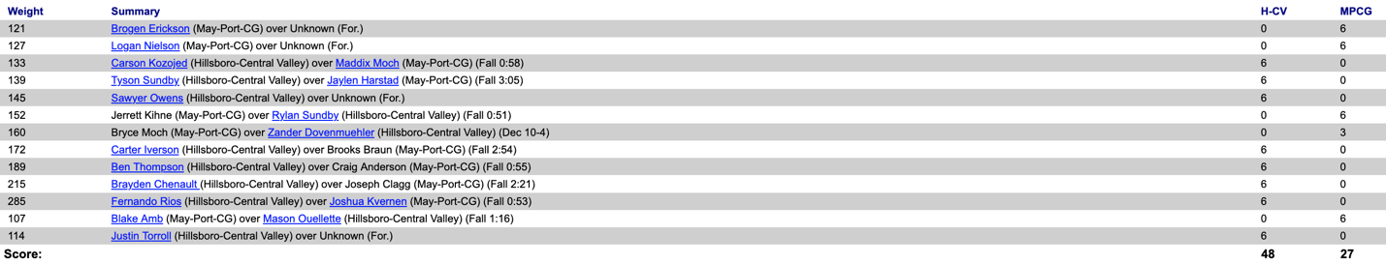
Hillsboro/CV 52 Northern Cass 18
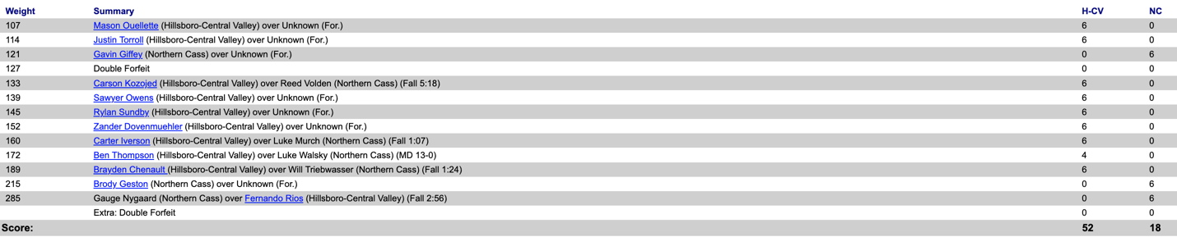
Hillsboro/CV 42 Roseau 34
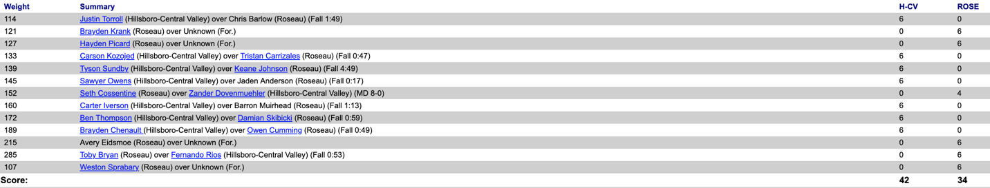
Roseau 42 MayPort-CG 36
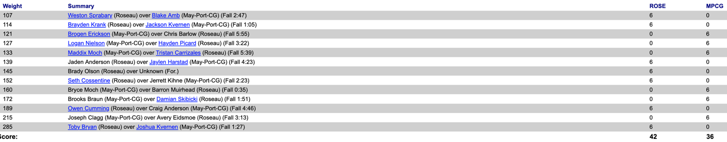
MayPort-CG 42 Northern Cass 30
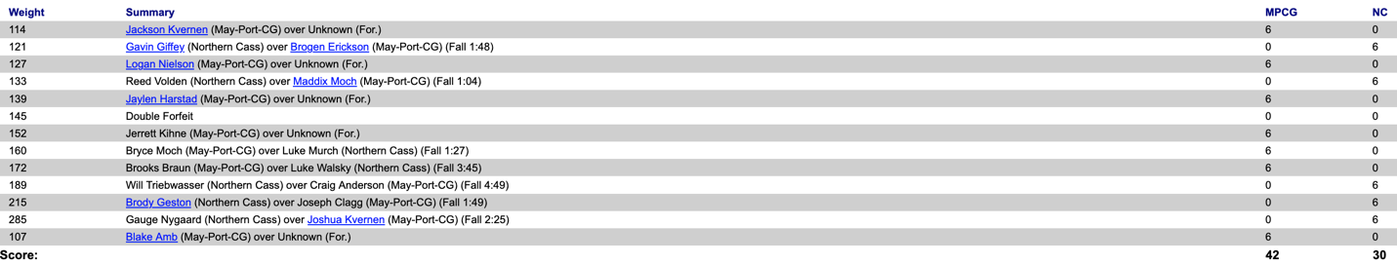
Roseau 54 Northern Cass 18
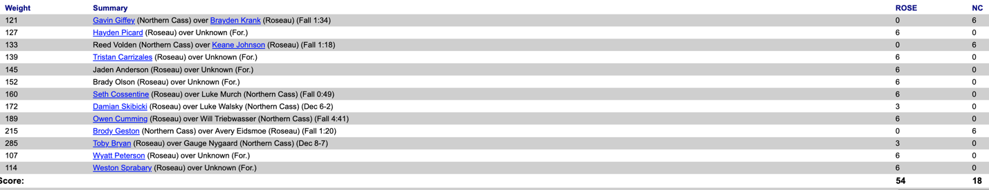
Williston 48 Mandan 27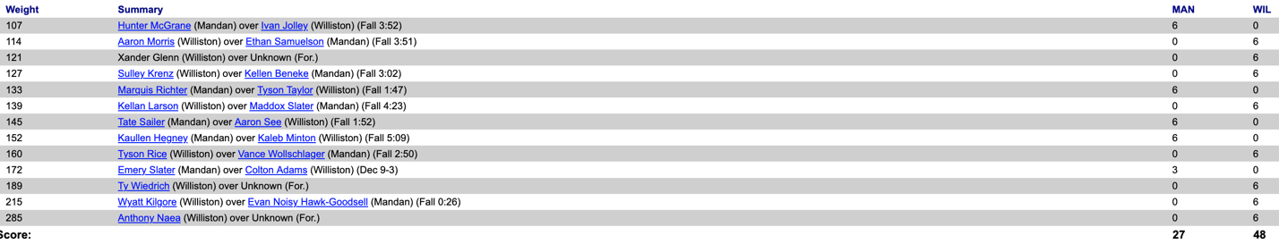
Velva 36 Rugby 3
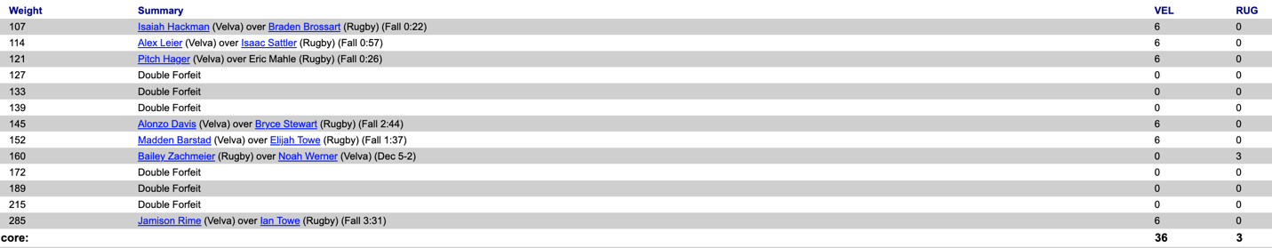
Velva 48 Stanley 18
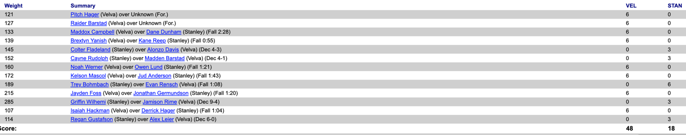
Stanley 45 Rugby 12
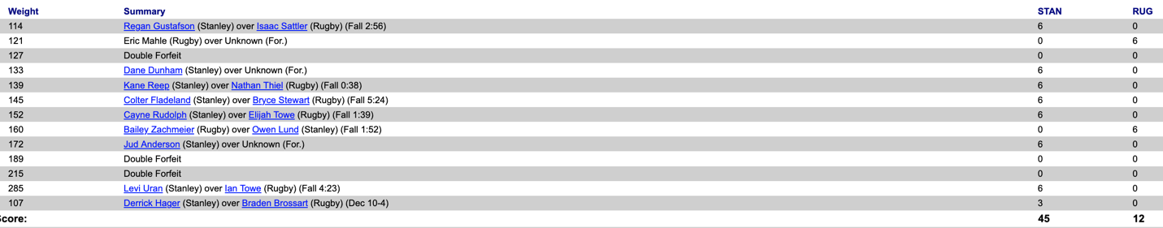
Minot 54 Jamestown 18
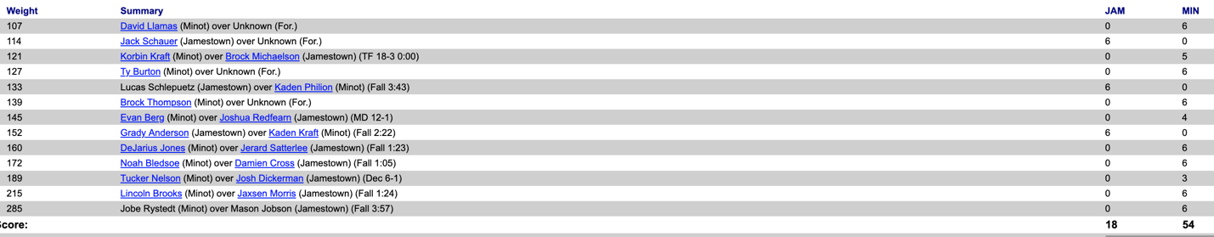
Williams Co 39 Bishop Ryan 18
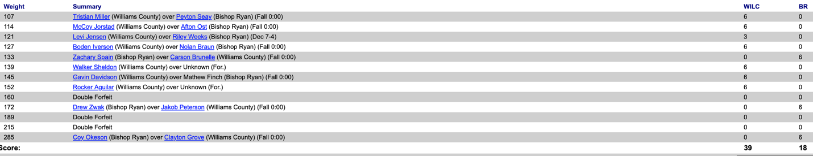
Williams Co 31 Des Lacs Burlington 31
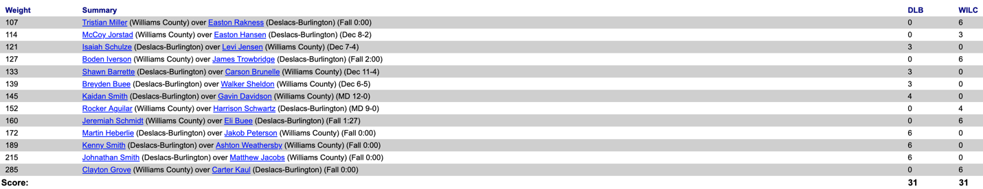
Lisbon 42 South Border 26
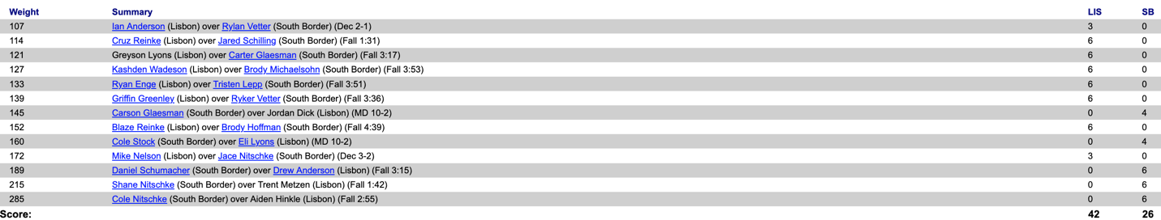
New Salem-Almont 45 Hettinger/Scranton 21
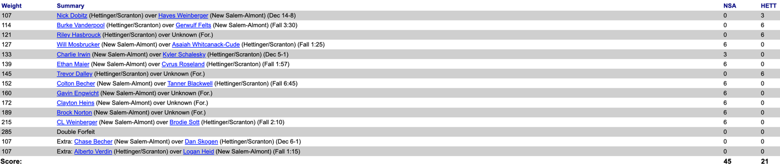
Northern Lights 32 Larimore 9
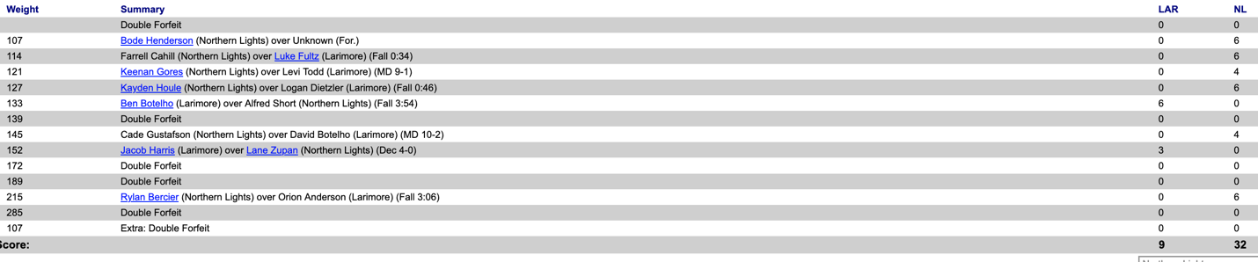
Larimore 30 Northwood 18
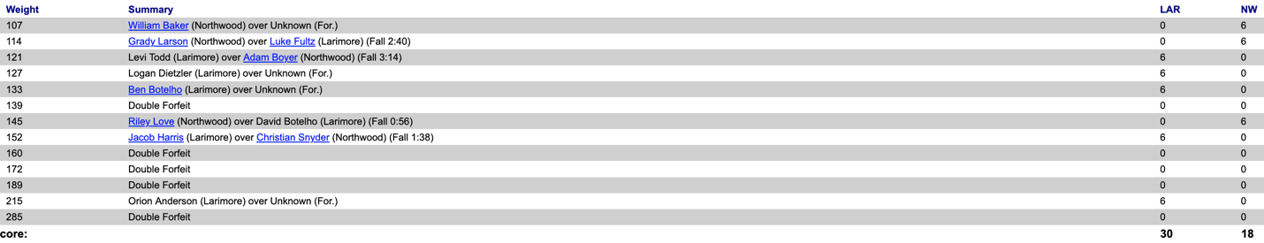
Northern Lights 25 Northwood 0
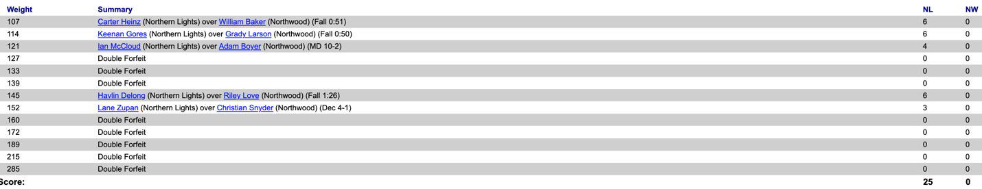

ND Girls Results
Bismarck 72 TMCHS 0
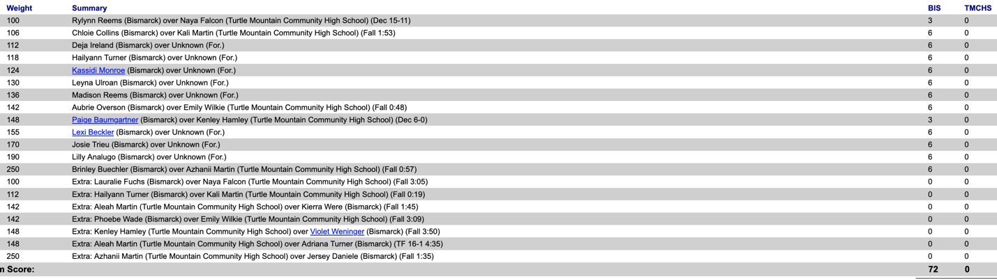
Minot 56 Jamestown 18
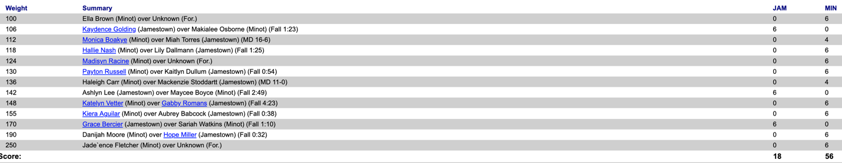
Central Cass 48 Napoleon 30
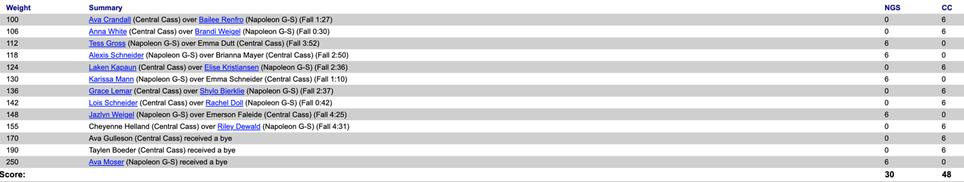
Napoleon 54 EEK 18
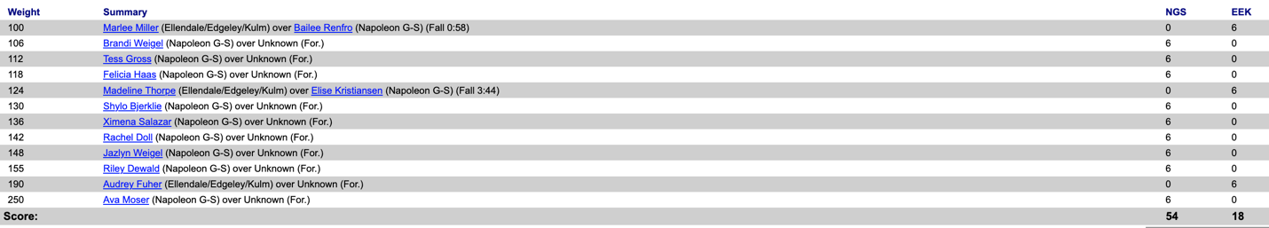
Central Cass 54 EEK 18
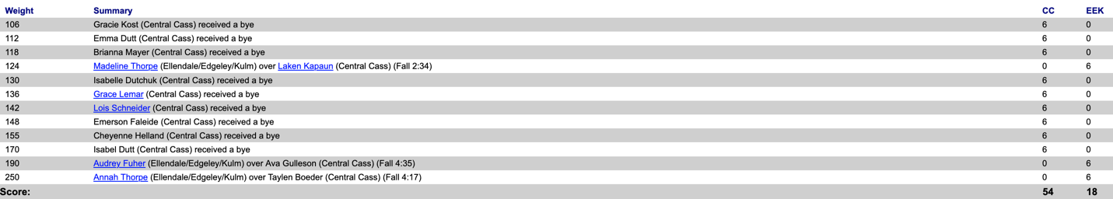
Mandan 12 Williston 11
Fargo 36 Mandan 32
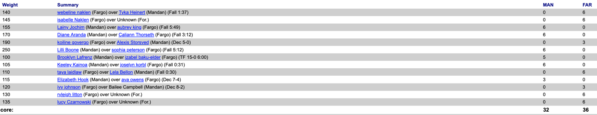
Lisbon 42 South Border 33
