Results from 1-9-24
ND
West Fargo Sheyenne 43 Grand Forks Central 21
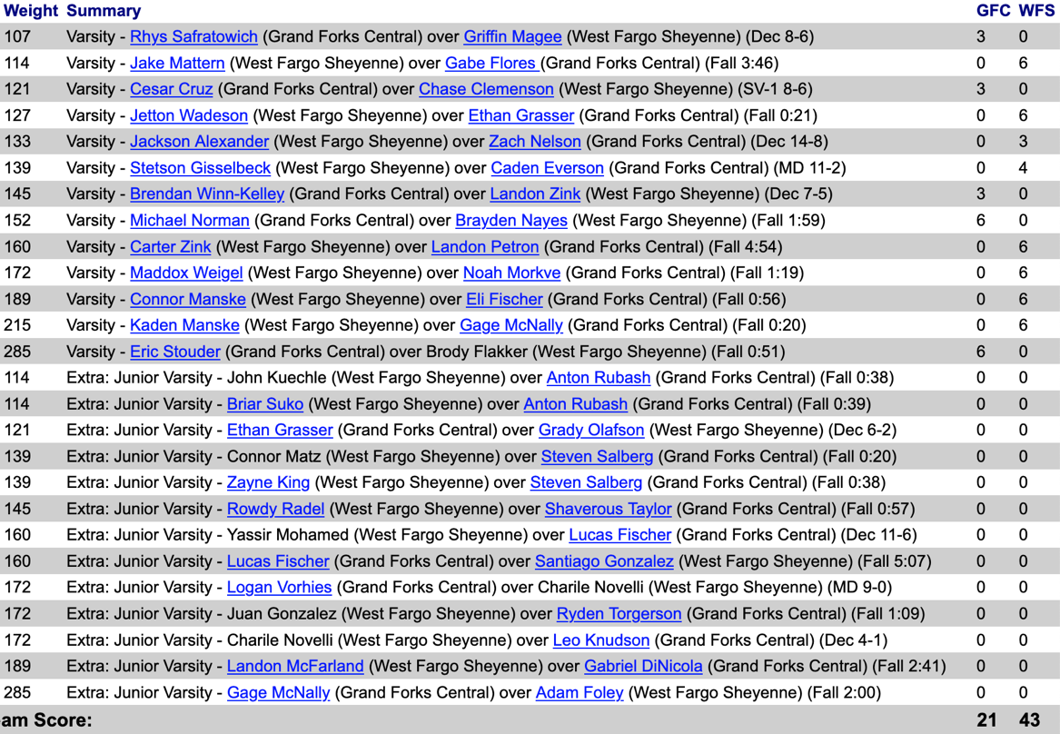

LISBON 40, KINDRED 17
107: Ian Anderson, Lis, won dec. over Gavin Rude 6-0. 114: Cruz Reinke, Lis, won by tech fall over Hayden Wieser 18-3. 121: Noach Swenson, Kin, won dec. over Greyson Lyons 4-1. 127: Kashden Wadeson, Lis, won dec. over Brock Johnson 4-0. 133: Ryan Enge, Lis, won major dec. over Jack McDonald 11-0. 139: Gabe Gruba, Lis, won dec. over Ryker Lachowitzer 3-1. 145: Fisher Johnson, Kin, won major dec. over Jordan Dick 12-4. 152: Blaze Reinke, Lis, pinned Jeremy Knight, 0:25. 160: Eli Lyons, Lis, major dec. over Tyson Johnson 13-2. 172: Mike Nelson, Lis, pinned Tanner Menge, 2:34. 189: Lincoln Swenson, Kin, major dec. over Drew Anderson 13-0. 215: Rodney Wolf, Kin, pinned Trent Metzen 0:38. 285: Aiden Hinkle, Lis, won by forfeit.

LISBON 40, NAPOLEON-GACKLE-STREETER 25
107: Ian Anderson, Lis, won by forfeit. 114: Dalton Feist, NGS, won dec. over Cruz Reinke 6-0. 121: Greyson Lyons, Lis, won by forfeit. 127: Open. 133: Brooks Grunefelder, NGS, pinned Gabe Gruba, 0:52. 139: Ryan Enge, Lis, won major dec. over Bryce Schneider 9-0. 145: Logan Feist, NGS, pinned Jordan Dick, 3:09.
152: Blaze Reinke, Lis, won by forfeit. 160: Mason Weigel, NGS, pinned Eli Lyons, 1:48. 172: Mike Nelson, Lis, won by forfeit. 189: Trent Metzen, Lis, won by forfeit. 215: Andre Doll, NGS, won major dec. over Drew Anderson 12-3. 285: Aiden Hinkle, Lis, won by forfeit.

KINDRED 51, NAPOLEON-GACKLE-STREETER 24
107: Gavin Rude, Kin, won by forfeit. 114: Dalton Feist, NGS, pinned Hayden Wieser, 1:14. 121: Noach Swenson, Kin, won by forfeit. 127: Brock Johnson, Kin, pinned Brooks Grunefelder, 1:29. 133: Jack McDonald, Kin, won dec. over Bryce Schneider 7-5. 139: Logan Feist, NGS, pinned Ryker Lachowitzer, 1:41. 145: Fisher Johnson, Kin, won by forfeit.
152: Jeremy Knight, Kin, won by forfeit. 160: Mason Weigel, NGS, pinned Tyson Johnson, 0:54. 172: Tanner Menge, Kin, won by forfeit. 189: Lincoln Swenson, Kin, won by forfeit. 215: Andre Doll, NGS, won by forfeit. 285: Rodney Wolf, Kin, won by forfeit.

GIRLS WRESTLING

LISBON 42, NAPOLEON-GACKLE-STREETER 36
100: Addison Bouman, Lis, won by forfeit. 106: Aurora Shelton, Lis, pinned Brandi Weigel, 3:22. 112: Arlie Ramerman, Lis, pinned Tess Gross, 3:40. 118: Alexis Schneider, NGS, pinned Adaleene Hansen, 5:02. 124: Elise Kristiansen, NGS, pinned Lyla Gillespie, 0:43. 130: Emersyn Schwab, Lis, pinned Shylo Bjerklie, 1:14. 136: Karissa Mann, NGS, won by forfeit.
142: Jazlyn Weigel, NGS, won by forfeit. 148: Brynlee Dewald, NGS, won by forfeit. 155: Ava Carlblom, Lis, pinned Riley Dewald, 0:48. 170: Nevaeh Buffett, Lis, won by forfeit. 190: Cora Oster, Lis, won by forfeit. 250: Ava Moser, NGS, pinned Ella Sad, 0:24.
Dickinson 63 Watford City 6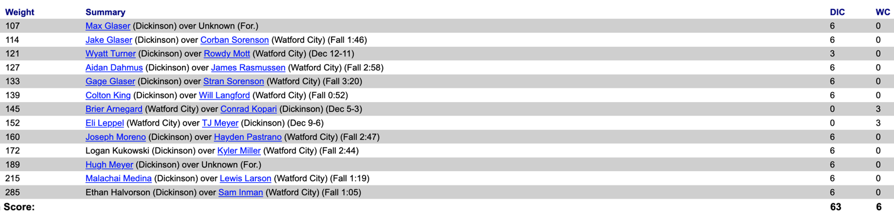
Dickinson 52 Mandan 15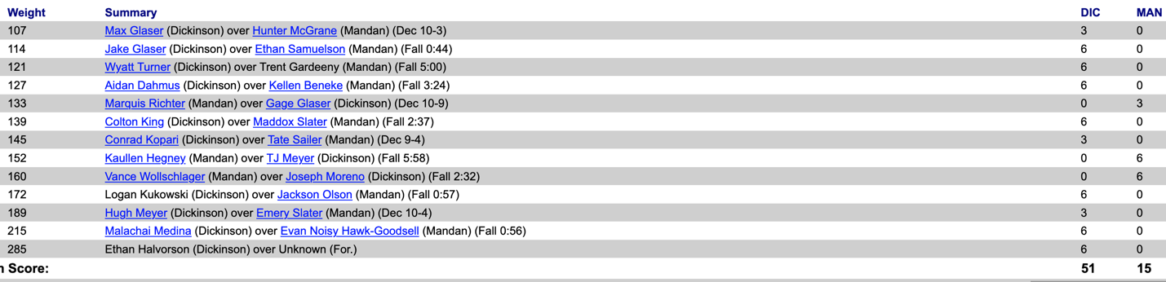
Mandan 51 Watford City 24 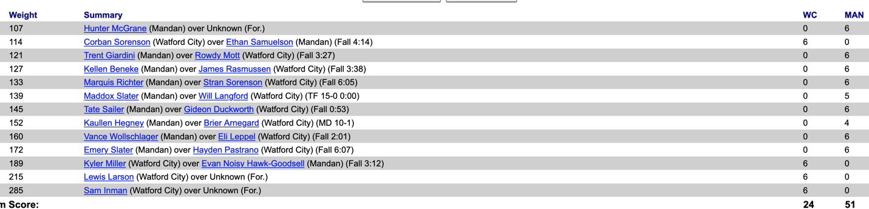
Killdeer 48 Hettinger-Scranton 23
Killdeer 45 Bowman Co/Beach 30
Beulah/Hazen 21Hettinger-Scranton 44

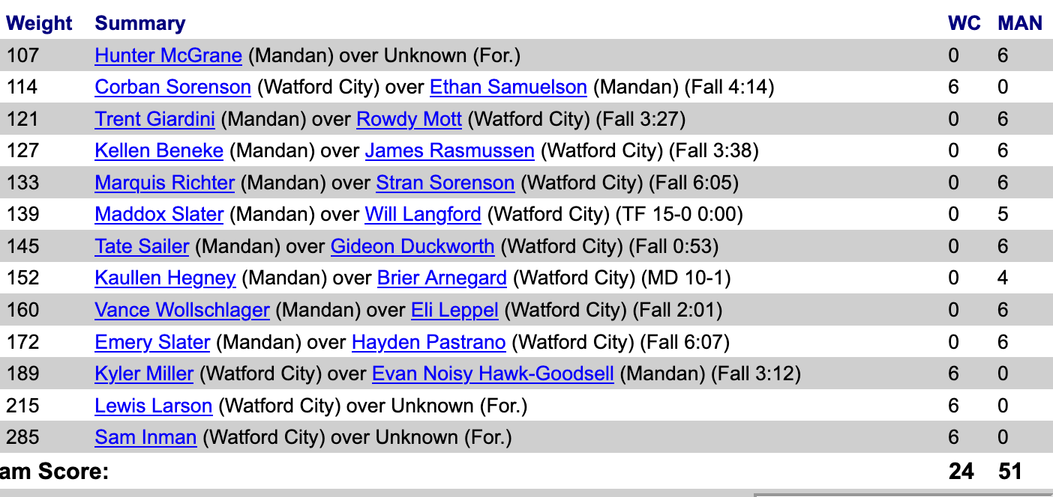
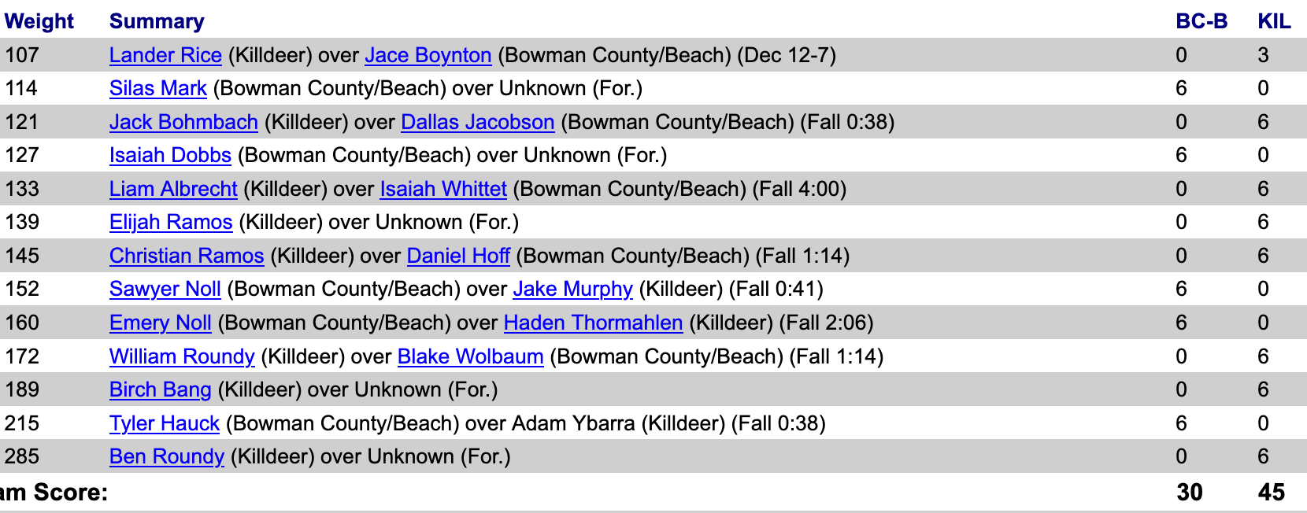
Bowman Co/Beach 45 Beulah/Hazen 27
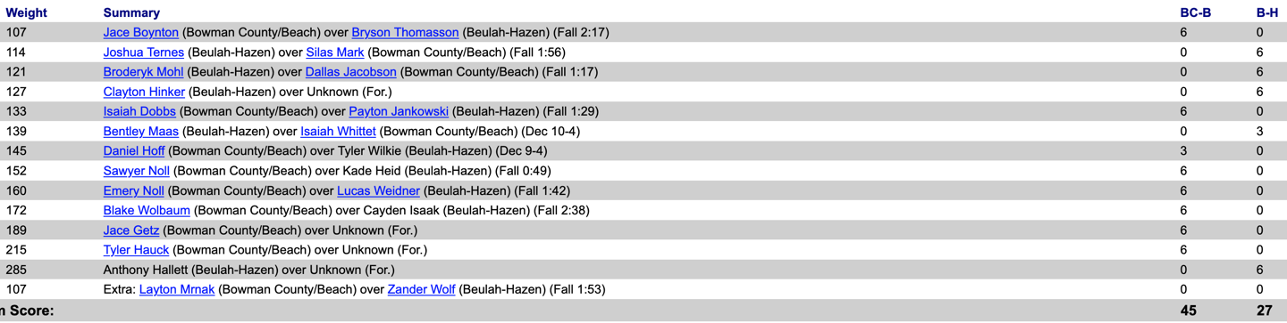

Roseau 45 Grafton 10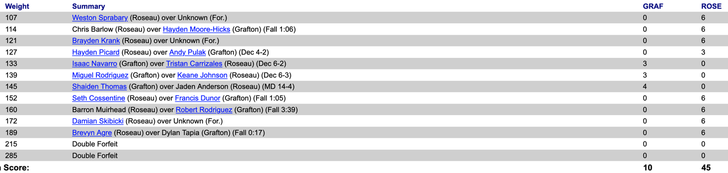
Grafton 36 Northwood 30
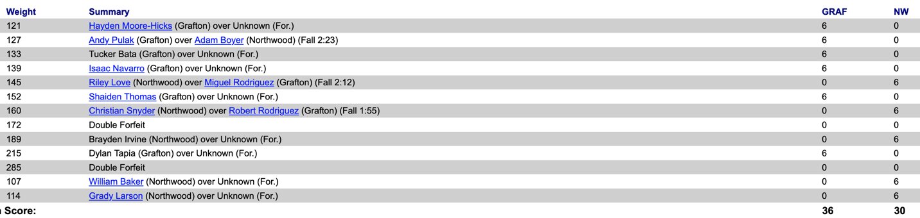
Roseau 54 Northwood 9
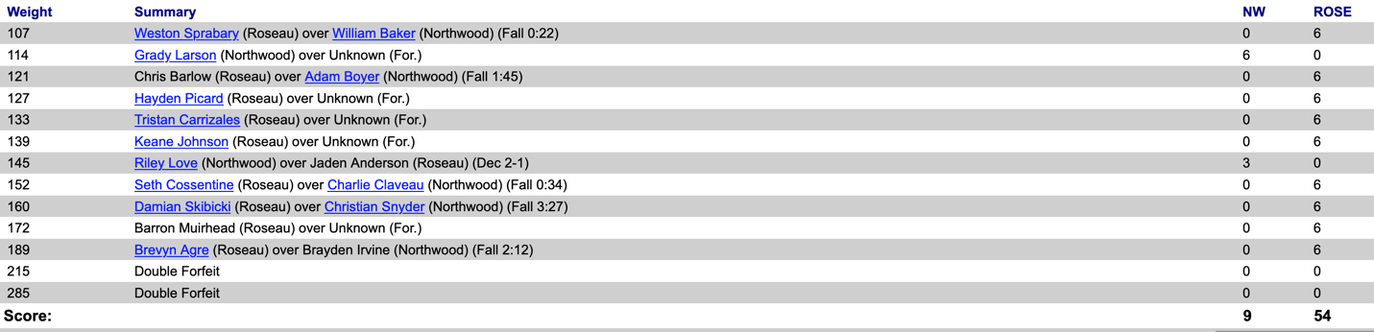

South Dakota
Potter Co 48 Sully Buttes 24
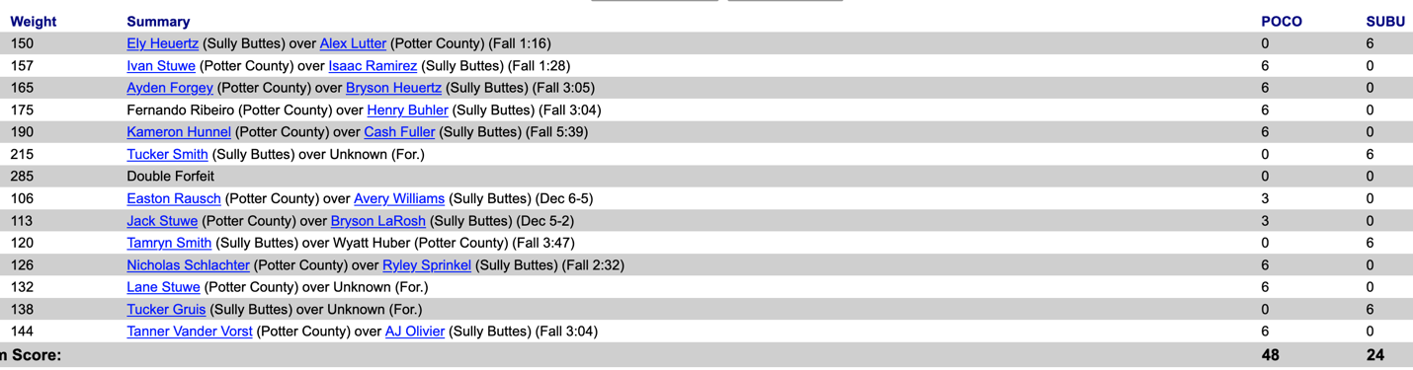

Brookings 47 Huron 25
